Religious Responses to the Black Death

https://www.worldhistory.org/article/1541/[Religious Responses to the Black Death - World History Encyclopedia](https://www.worldhistory.org/article/1541/religious-responses-to-the-black-death/)

The [**Black Death**](https://www.worldhistory.org/Black_Death/) of 1347-1352 CE is the most infamous [**plague**](https://www.worldhistory.org/disambiguation/plague/) outbreak of the medieval world, unprecedented and unequaled until the 1918-1919 CE flu pandemic in the modern age. The cause of the plague was unknown and, in accordance with the general understanding of the Middle Ages, was attributed to supernatural forces and, primarily, the will or wrath of [**God**](https://www.worldhistory.org/God/).

Accordingly, people reacted with hopeful cures and responses based on religious belief, folklore and superstition, and medical knowledge, all of which were informed by Catholic [**Christianity**](https://www.worldhistory.org/christianity/) in the West and [**Islam**](https://www.worldhistory.org/islam/) in the [**Near East**](https://www.worldhistory.org/Near_East/).

**THE PERCEIVED FAILURE OF GOD TO ANSWER PRAYERS CONTRIBUTED TO THE DECLINE OF THE CHURCH'S POWER & THE EVENTUAL SPLINTERING OF A UNIFIED CHRISTIAN WORLDVIEW.**

No matter how many Jews, or others, were killed, however, the plague raged on and God seemed deaf to the prayers and supplications of believers. In [**Europe**](https://www.worldhistory.org/europe/), the perceived failure of God to answer these prayers contributed to the decline of the [**medieval Church**](https://www.worldhistory.org/Medieval_Church/)'s power and the eventual splintering of a unified Christian worldview during the [**Protestant Reformation**](https://www.worldhistory.org/Protestant_Reformation/) (1517-1648 CE). In the East, Islam remained intact, more or less, owing to its insistence on the plague as a gift which bestowed martyrdom on the victims and transported them instantly to paradise as well as the view of the disease as simply another trial to endure such as famine or flood.

### **The Black Death Origin & Spread**

The plague originated in Central Asia and spread via the [**Silk Road**](https://www.worldhistory.org/Silk_Road/) and troop movements throughout the Near East. The first recorded outbreak of bubonic plague is the Plague of Justinian (541-542 CE) which struck [**Constantinople**](https://www.worldhistory.org/Constantinople/) in 541 CE and killed an estimated 50 million people. This outbreak, however, was simply the furthest westerly occurrence of a disease that had been stalking the people of the Near East for years before. The historian John of [**Ephesus**](https://www.worldhistory.org/ephesos/) (l. c. 507 - c. 588 CE), an eyewitness to the plague, notes that the people of Constantinople were aware of the plague for two years before it came to the [**city**](https://www.worldhistory.org/city/) but made no provision against it, believing it was not their problem.

After Constantinople, the plague died down in the East only to appear again with the Djazirah Outbreak of 562 CE which killed 30,000 people in the city of Amida and even more when it returned in 599-600 CE. The disease maintained this pattern in the East, seeming to disappear only to rise again, until it picked up momentum beginning in 1218 CE, further in 1322 CE, and was raging by 1346 CE.

**[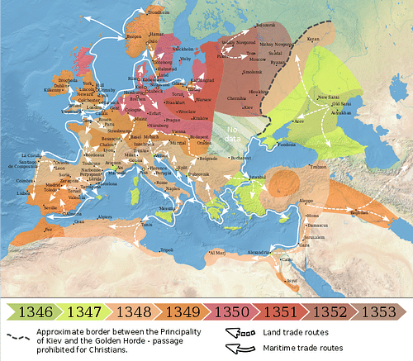](https://www.worldhistory.org/image/8954/spread-of-the-black-death/)**

[Spread of the Black Death](https://www.worldhistory.org/image/8954/spread-of-the-black-death/)

[Flappiefh (CC BY-SA)](https://www.worldhistory.org/image/8954/spread-of-the-black-death/)

It was around this time that the [**Mongol**](https://www.worldhistory.org/Mongol_Empire/) Khan Djanibek (r. 1342-1357 CE) was laying siege to the port city of Caffa (modern-day Feodosia in Crimea) which was held by the Italians of Genoa. As his troops died of plague, Djanibek ordered their corpses catapulted over Caffa's walls, thereby spreading the disease to the defenders. The Genoese fled the city by ship and so brought the plague to Europe. From ports such as Marseilles and Valencia, it spread from city to city with every person who had had contact with anyone from the ships and there seemed no way to stop it.

### **Christian vs. Muslim View of Plague**

Responses to the plague were informed by the dominant religions of West and East as well as the traditions and superstitions of the regions and presented as a narrative which explained the disease. Scholar Norman F. Cantor comments:

The scientific method had not yet been invented. When faced with a problem, people in the Middle Ages found the solution through diachronic (as opposed to synchronic) analysis. The diachronic is the historical narrative, horizontally developing through time: “Tell me a story”. With their fervent historical imagination, medieval people were very good at giving diachronic explanations for the outbreak of bubonic plague. (17)

Reactions, then, were based on the religious narratives created to explain the disease and fall, generally, into three beliefs about the plague held, respectively, by medieval Christianity and Islam. Even empirical observation was informed by religious belief, as in the case of whether the plague was contagious.

**Christian View:**

* The plague was a punishment from God for humanity's sins but could also be caused by “bad air”, witchcraft and sorcery, and individual life choices including one's piety or lack of it.
* Christians – especially in the early period of the outbreak – could leave a plague-stricken region for one with better air which was not infected.
* The plague was contagious and could be passed between people, but one could protect oneself through prayer, penitence, charms, and amulets.

**Muslim View:**

* The plague was a merciful gift from God which provided martyrdom for the faithful whose souls were instantly transported to paradise.
* Muslims should not enter, nor should they flee from plague-stricken regions but should remain in place.
* The plague was not contagious because it came directly from God to specific individuals according to God's will.

Again, these are general views held by the majority and not every cleric of Europe or the Near East agreed with them nor did every layperson. These beliefs, however, carried enough weight with believers to encourage responses which – again, generally – fall into five main reactions.

**Christian Response:**

* Penitential processions, attending mass, fasting, prayer, use of amulets and charms
* The Flagellant Movement
* Supposed cures and fumigation of “bad air”
* Flight from infected areas
* Persecution of marginalized communities, especially the Jews

**Muslim Response:**

* Prayer and supplication at mosques, processions, mass funerals, orations, fasting
* Increased belief in supernatural visions, signs, and wonders
* Magic, amulets, and charms used as cures
* Flight from infected areas
* No persecution of marginalized communities, respect for Jewish physicians